Cambria Redmond
7817 Elmwvood Place Denver CO
December 04,2020
Joshua Wayland, PhD
Surface Transportation Board
c/o ICF
9300 Lee Highway
Fairfax, VA 22031
Attention: Environmental filing, Docket No. FD 36284

Dear Dr. Wayland and to whom it may concern,
Hello, My name is Cambria Redmond, I am currently a senior undergraduate studying Biology and Integrative Health Care at Metropolitan State University of Denver in Colorado with a specialization in Environmental Sciences. I am writing in concern for the Construction of Uinta Basin Railway.
As a Utah native, growing up in Southern St. George, I had always maintained a deep gratitude for the wide open spaces and the ease with which we may walk into those green spaces. I felt this especially when standing upon the unique landscape and habitat of the ‘Isolated Empire’. This is my purpose in commenting on the proposed plan; changing undeveloped land and land used for public recreation, wildlife habitat, agriculture, and grazing, to land for rail construction and operation should not be taken lightly nor should it be undertaken as hastily as 2021, such that this proposal projects. A myriad of issues arise with regard to future economic and ecological stratifications affirmed by the EIS, such will be highlighted to describe the devastation that each route alternative could pose to Utah’s future prosperity.
One of the biggest issues with regard to construction of this railway is that of Environmental Impacts. Many commenters have given insight to indelible ramifications upon already suffering soil, water, and air quality of all proposed project site areas. Upon EIS review, it was determined that air quality was unaffected. Such analyses were woefully inadequate, as they failed to assess what effect increased refinery( of crude oils) as a result of production would have upon greenhouse gas emissions and subsequent air quality loss. Such losses of soil air and water quality can not be feasible when looking beyond the next two decades. Furthermore, with regard to endangered threatened and special status animals we must realize that any losses of habitat, especially from already isolated and fragmented areas must mean devastating consequences. Regardless of mitigative tactics provided through replanting of native plant species and subsequent plans of reformation, the projected losses during construction are striking; especially by way of fire, through loss and degradation of drought resistant shrubs. Native vegetation, particularly the Colorado Plateau Mixed Low Sagebrush Shrubland vegetation community, and woodlands also the Colorado Plateau Pinyon-Juniper Woodland vegetation community) would be most affected by any of the Action Alternatives provided, fostering a loss or stressor upon these fire resistant species could provide a horrible fate for surrounding areas.
Despite consultation with multiple agencies and affiliates, federal and state, many indigenous tribes either had no comment or declined the multiple invitations to comment. The only Tribe that participated in the process was the Ute Tribe who is also an equity partner in the project. Two of the proposed alternatives cut through reserved tribal lands that have already seen much dwindling acreage in the past century. Private profit and easement for petroleum should not be a reason to further strip land and mineral rights.
I must ask... why must we continue to invest and reform natural landscapes for the sake of propagation and sustenance of an unsustainable practice? Hydraulic Fracturing has been seen to have negative ecological impacts upon animals and surrounding municipal agricultural areas, these trends have been highlighted in countless esteemed peer reviewed literature (Souther et al. 2014; Keighley D. 2015).
Instead of investing 1.4 billion dollars to construct a railway, which will not be built, utilized and maintained by public or governmental entities, but by private firms that intend its sole use for the escalation of extraction and transport of oil and gas and minerals should be cause for concern- our public lands should not be at the mercy of merchants with no true value provided to the community.
For all the grievances aforementioned, I request to petition for the No Action Alternative denying the request of the coalition for operation authority over this proposed railway. There are countless viable options for diversifying markets, raising revenues and increasing employment, as the Coalition so advocates for this project, but these are everlasting ecological effects that provide no true sustainable benefits. Extraction and Economic Markets should not be established just because the resource is vastly available in the basin, the land has innate value and new and emerging energy markets would provide more lucrative opportunity of continual service and expansion. Perhaps divestment is overdue, countless sustainable substitutes have been proven to be not merely economically viable but advantageous. 50-100 permanent railway jobs does not justify the upwards of 10,000 acres of undisturbed habitat that would be demolished. Muradov N. (2015) provides a systematic model for transition to a more robust productive and green market, yes more efficient transportation is needed, but antiquated intents of industry can no longer be a justified driver of land management and construction.

References:

Keighley D. Phosphatic Carbonate Shale of the “Bird’s Nest Saline Zone”, Upper Green River Formation, Uinta Basin, Utah. In: Dordrecht: Springer Netherlands. 251-76.

McCaffery RM, Reisor R, Irvine K, Brunson J. Demographic monitoring and population viability analysis of two rare beard tongues from the uinta basin. Western North American naturalist. 2014;74(3):257–274.

Muradov N. 2014. Transition to Low- and Zero-Carbon Energy and Fuels. Springer New York. 279-323.
Souther S, Tingley MW, Popescu VD, Hayman DTS, Ryan ME, Graves TA, Hartl B, Terrell K. Biotic impacts of energy development from shale: research priorities and knowledge gaps. Frontiers in ecology and the environment. 2014;12(6):330–338.

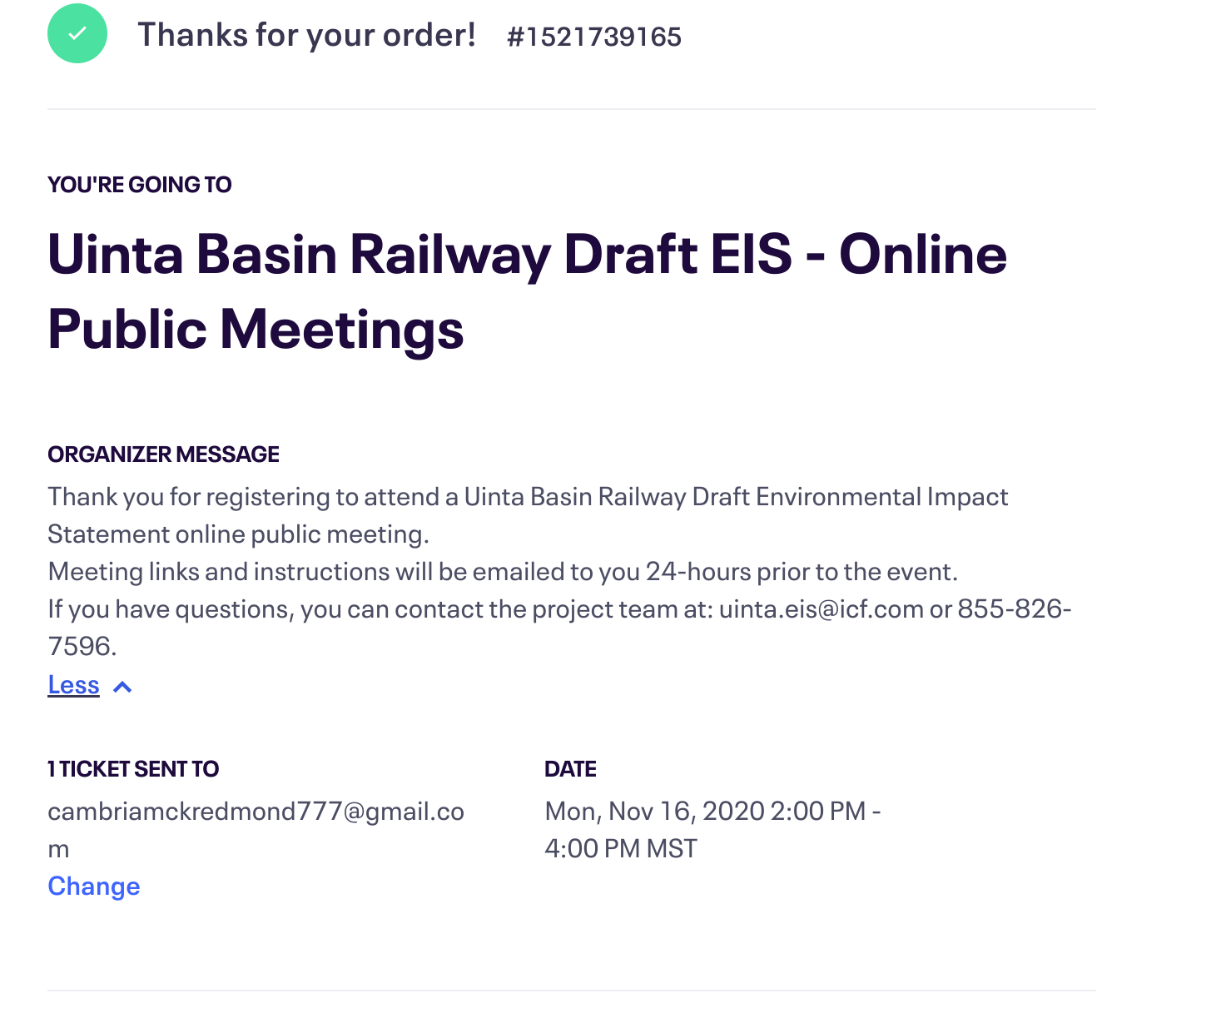
- https://cdxnodengn.epa.gov/cdx-enepa-II/public/action/eis/details?reisId=255673
Gave Verbal Comment at this last one

